Coordinator hiring history has shortchanged Black coaches, including at Georgia, Georgia Tech
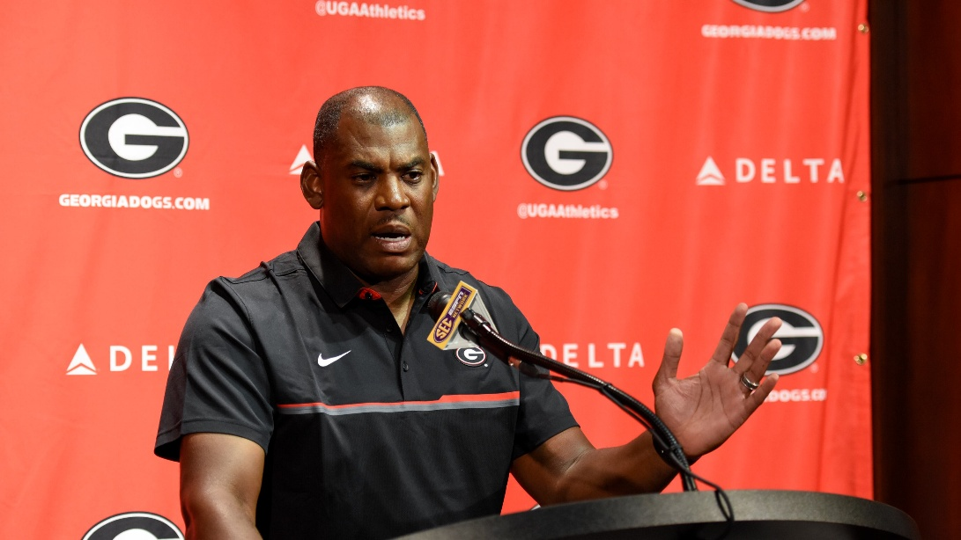
Georgia defensive coordinator Mel Tucker speaks during a press conference at Butts-Mehre Heritage Hall in Athens, Georgia, on Saturday, August 6, 2016. (Photo/David Barnes)
By Ken Sugiura
Updated March 3, 2025
At 82, Bill Curry has reached a stage in his life where he has begun to look back and reflect. Not all of his reflections bring him comfort, however.
Among his regrets: Across his 20-year career as a head coach at Georgia Tech, Alabama, Kentucky and Georgia State, there were Black assistant coaches on his staff that he should have promoted to offensive or defensive coordinator, but did not.
“You can point at guys that would have been on my staff that would have been terrific coordinators,” Curry told The Atlanta Journal-Constitution. “I’ve thought about the very same thing. Why didn’t I do it? Well, I don’t know.”
Curry’s decisions to hire white coaches as coordinators while failing to give a shot to deserving Black coaches fit a pattern that has been repeated not only at Tech and his following posts but at Georgia and across football.
Fans who follow either the Yellow Jackets or Bulldogs likely are aware that neither school has had a Black head football coach, which unfortunately puts them on par with most of their SEC and ACC peers. Both leagues were integrated more than 50 years ago. Black athletes have come to excel and fill the most roster spots and Black coaches have earned an increasing share of assistant coach positions. However, Tech and UGA are among 20 of the 33 ACC and SEC schools that have yet to hire their first full-time Black head coach.
Arguably more staggering is the number of Black coaches who have been offensive or defensive coordinator at UGA and Tech — the most prominent, important and well-paying coaching jobs on a coaching staff after head coach, and positions that come open with more frequency — in both schools’ history.
UGA: Two.
Tech: One.
Since Georgia’s team was integrated in 1971, the program has hired an offensive or defensive coordinator no less than 23 times. Defensive coordinators Kevin Ramsey in 1999 and Mel Tucker in 2016-18 were the only two Black hires.
“That (stuff) has passed,” said Ray Donaldson, a Bulldogs captain and trailblazing center at UGA in the late 1970s and in the NFL. “Give us a shot. That’s all we ask for, is a shot.”
At Tech, there have been at least 40 offensive or defensive coordinator hires since Eddie McAshan became the first Black scholarship athlete to start for the Jackets in 1970, the most recent in February with coach Brent Key hiring former Texas safeties coach Blake Gideon as defensive coordinator. Brian Baker remains the sole African American coach to fill one of the coordinator roles, in 1995.
“That’s terrible,” said Joe Harris, Tech’s first Black captain in 1974. “It is what it is. Maybe we can work on that, get some exposure out there. Let them know that our coaches, we need to have better opportunities in the leadership areas.”
In this regard, Tech and Georgia again are not dissimilar from others in the two conferences. Based on information from a 2021 ESPN report and additional reporting to bring it up to date, Alabama, LSU, N.C. State, Virginia Tech and Cal are programs that all had two or fewer Black offensive or defensive coordinators through the 2024 season dating to 1981, which was the starting point of the ESPN study. The pattern is not limited to the SEC and ACC. For example, Wisconsin and Penn State both have had only two Black offensive or defensive coordinators going back to 1981. (For the sake of clarity, the totals do not count co-coordinators if a full coordinator was on staff.)
It is not for a lack of candidates. According to data compiled by the NCAA and the Institute for Diversity and Ethics in Sport at the University of Central Florida, Black athletes have comprised at least 40% of Division I football teams dating back at least to 1991 and surely further back than that. Black coaches made up 20% of assistants and 5% of head coaches in Division I in 1999. In the 2024 season, the percentage of Black assistant coaches (outside of offensive and defensive coordinators) had risen to 43%. But Black coaches held only 26% of Division I defensive coordinator jobs in 2024, 11% of offensive coordinator positions and accounted for 16% of the level’s head coaches. The numbers were even smaller at the power-conference level — 16%, 9% and 12%.

“I think what would help a lot is if (head coaches) trust the work that they see men around them putting in regardless of color,” a Black assistant coach at the FBS level told The AJC. “I’ve sat and watched myself guys do a really good job at what they do and end up stuck in a certain spot while I’ve seen people who are not as good elevate because they know the right person or people. It doesn’t make sense to me.”
This is not to say that either institution has deliberately limited opportunities for Black coaches, at least since the schools’ athletic programs were integrated.
Both Tech and Georgia, for instance, have both employed two African American coaches for men’s basketball. In 2003, Georgia made Damon Evans the first Black athletic director in SEC history. Key’s head strength-and-conditioning coach, A.J. Artis, is a Black man in a position mostly occupied by white coaches. UGA coach Kirby Smart helped prepare three Black coaches on his staff, Tucker, Dell McGee and Fran Brown, to become head coaches elsewhere.
“But they clearly haven’t gone out of their way to recruit a pool that allowed the numbers to change,” said Richard Lapchick, the renowned president of the Institute for Sport and Social Justice (TIDES).
As he asks himself why he made the hiring decisions the way he did, Curry is contrite.
“We can all talk about how we don’t suffer from those prejudices and things, but there are times when we need to pray on it more and look inside harder and be more thorough in our searches,” Curry said. “I include myself in that evaluation. I wish we had done better. We can do better now if we just will.”
It’s easy to understand how it happens, and it isn’t even necessarily nefarious. Typically, a head coach will entrust the two most important jobs on the staff to coaches he knows well and feels comfortable with. The hire often must be made quickly. Coaches are under heavy pressure to get the moves right.
The safe choice is to stick with coaches in their circle. A white coach’s network likely will include more white colleagues, just as the same would hold with Black coaches and their circles.
“I do feel like the good ol’ boy system, it’s a real thing,” the Black assistant coach said. “Guys hire their buddies, then the buddy hires a buddy and then, before you know it, it’s an office full of buddies.”
Or, if the coach goes outside his network, he’s likely to first look for a coach with coordinating experience. From a probability standpoint, that coach likely will be white. Repeat the process for 50 years, and this is what you get.
Unless you’re of a mind that you don’t think Black coaches are as deserving — and heaven help you if you do — it is difficult to draw any conclusion other than that the system has failed Black coaches. It is lamentable how many African American coaches have missed out on a chance to demonstrate their superior coaching ability and earn even greater opportunities and the income that would have accompanied them.
“I know there are plenty of (Black coaches) out there capable of doing the job,” said Donaldson, the Georgia offensive line great, now retired and living in Indianapolis. “You give us a chance, we’ll work it for you. We’ll fix it for you.”
You don’t even have to be a supporter of initiatives that promote fairness in hiring to understand the need for an improved process. All you really have to be is a fan of any team that has failed to be more inclusive and thorough in its hiring practices. Think about ineffective play-callers that your team has had in the past 50 years, maybe someone who was a close friend of the head coach. Now imagine how much better your team would have been if it had been more thorough in broadening the pool of candidates and found superior candidates.
Maybe he would have been Black, maybe not. But, over time, chances are there would have been more Black coordinators receiving the shots that they had earned. And, presumably, some of them would have done well enough to become head coaches somewhere.
Lapchick, the TIDES president, recommends that schools mandate the inclusion of coaches of color as candidates when hiring coordinators. Another solution is for head coaches to intentionally seek out qualified Black candidates for graduate assistantships or other low-level positions to help coach quarterbacks and linebackers.
The surest path to becoming an offensive or defensive coordinator is to be a quarterbacks or linebackers coach, respectively. And the way to coach those positions is to gain experience at them.
As of Sunday, the 32 ACC and SEC schools whose football staffs were posted on their websites (North Carolina is the exception) listed a total of 43 coaches or staff with quarterback responsibilities in their titles, from offensive coordinator/quarterbacks coach to quarterbacks graduate assistant.
Of the 43, 40 are white and two are Black. (The 43rd, Kentucky offensive coordinator and quarterbacks coach Bush Hamdan, is of Middle Eastern and Asian descent, according to a Lexington Herald-Leader story.) That includes 17 of the 18 coaches at the top of that ladder, coaches who were both offensive coordinator and quarterbacks coach.
That is absolutely jaw-dropping. If that’s where future head coaches are coming from, why should anyone expect the disparity to change?
Unless there’s an enormous gap in the number of white and Black coaches or unless white coaches are nearly always better candidates than Black counterparts, how does this not strike anyone as a system that needs fixing?
Key and Smart don’t necessarily bear responsibility to champion the cause of Black coaches. But a certain 82-year-old predecessor of Key’s at Tech would surely advise them that they don’t want to have to look back in 30 years and regret that they could have done more.
Bill Curry might tell them that they and their schools can do better now if they just will.

